Cyclic number

Def

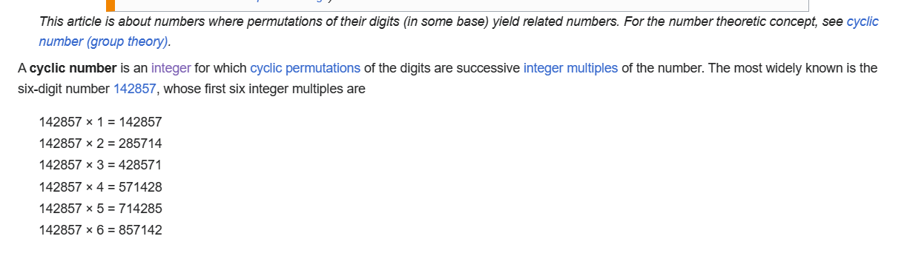

A cyclic number refers a natural number for which cyclic permutations of the digit are successive integer mutliples of the number.

With mathematically expression, one can express it as follows.

Given $$n>0$$ where $$n$$ = $$n_{d−1}{10}^{d−1}+…+n_{1}{10}^{1}+n_{0}{10}^{0}$$, $$d$$ is the number of digit of $$n$$ and $$n_{i} != n_{j}$$ for all $$1≤i,j≤d$$ and $$i,j$$ is a natural number , $$i != j$$ (i.e. the digit of the number of $$n$$ is unique.

Then, the following holds.

For any $$b$$ in the set $$\left\{1,2,…,d\right\}$$ (i.e. )

with $$m$$ = $$m_{d^{′}−1}{10}^{d^{′}−1}+…+m_{1}{10}^{1}+m_{0}{10}^{0}$$, $$d^{′}$$ is the number of digit of $$m$$, one has

1. $$m_{d^{′}−i}$$ = $$n_{b−i}$$, for all $$0≤i≤b$$ (here, $$b$$ $$≤$$ $$d^{′}$$ = $$d$$, so the subscription of them do not cause exception )
2. $$m_{i}$$ = $$n_{b+i}$$, for all $$1≤i$$ and $$b+i≤d$$.

Property

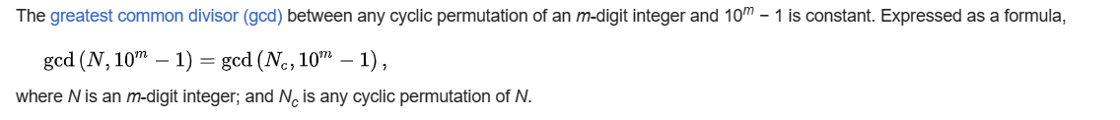

Proof

First, one has to prove the claim 1.

$$\gcd\left(a,c\right)$$ = $$\gcd\left(a+r,c\right)$$ for all $$c>r>0$$, when $$0<a<c$$ and $$0<a+r<c$$

Proof of claim 1

Let $$c=aq_{0}+r_{0}$$ where $$0≤r_{0}<a$$ (by division theorem) and $$c=\left(a+r\right)q_{1}+r_{1}$$ where $$0≤r_{1}<a+r$$

Then

$$aq_{0}+r_{0}=\left(a+r\right)q_{1}+r_{1}$$

=> $$aq_{0}+r_{0}=aq_{1}+rq_{1}+r_{1}$$

=> $$a\left(q_{0}−q_{1}\right)=rq_{1}+r_{1}−r_{0}$$

Case 1:

=> $$a=\frac{rq_{1}+r_{1}−r_{0}}{\left(q_{0}−q_{1}\right)}$$, for all $$q_{0} !=q_{1}$$

=> $$c=aq_{0}+r_{0}$$

=> $$c=\frac{rq_{1}+r_{1}−r_{0}}{q_{0}−q_{1}}⋅q_{0}+r_{0}$$

=> $$c=\frac{rq_{1}}{q_{0}−q_{1}}q_{0}+\frac{r_{1}}{q_{0}−q_{1}}q_{0}−\frac{r_{0}}{q_{0}−q_{1}}⋅q_{0}+r_{0}$$

=>

Case 2:

=> $$0=rq_{1}+r_{1}−r_{0}$$, if $$q_{0}=q_{1}$$

=>

Ref

[Cyclic number - Wikipedia](https://en.wikipedia.org/wiki/Cyclic_number)

[Transposable integer - Wikipedia](https://en.wikipedia.org/wiki/Transposable_integer)